JAYLBRO BORDER COLLIES
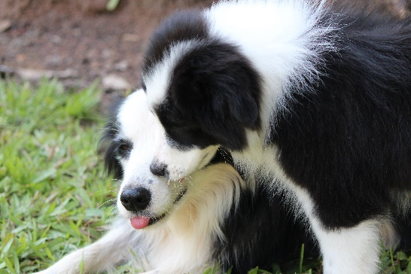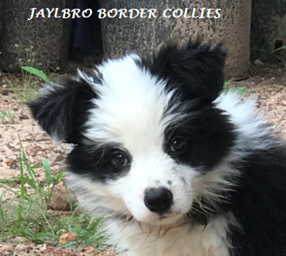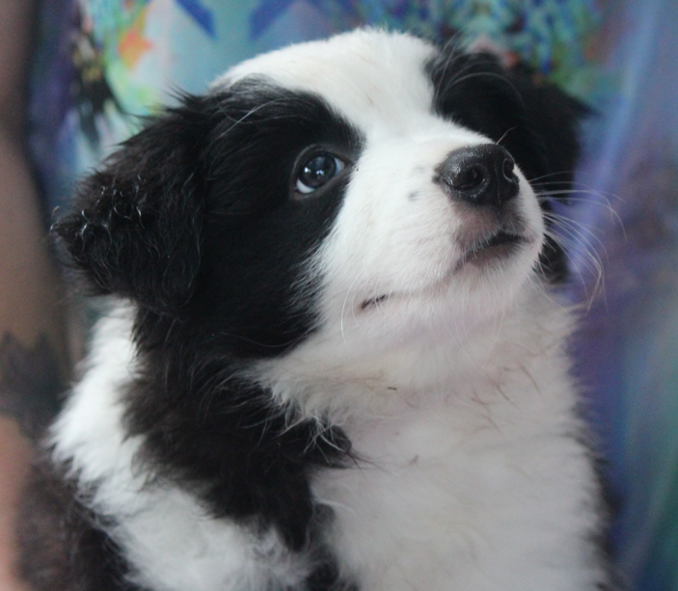

Please complete and return this puppy questionnaire
As a registered breeder I provide my puppies and rehoming adults with the best homes possible.
A border collie is a life commitment and they are an active breed who have medium double coats, so shedding is an issue.
They are a loyal and intelligent breed who thrive on exercise and training is a requirement because if they become bored this may will lead to digging, barking, chewing etc
You may find some of these questions confronting or intrusive, however please don’t be over whelmed by what I ask. You are free not to answer these questions, but please understand I also free not to sell you a puppy.
In completing this questionnaire will help me in placing a puppy in the best home I see appropriate as not every personality is the same.
In most cases, puppies will be registered with Dogs NT on the “Limited Register” (This means no showing or breeding), but you are still able to compete in obedience, agility, retrieving, working dog, flyball Trials. However, if you request a puppy for Mains Register this can be discussed.
Puppies will have their 1st vaccination, be wormed, microchipped and vet checked before leaving for their new home at 8 weeks of age.
Parents are DNA tested or clear by parentage for CEA, CL & TNS. They are also hip & elbow scored. You are welcome to see any of this documentation on request.
Puppy packs are given with every puppy. They consist of a toy, sample pack of kibble and a feeding guide.

Name:
Phone:
Email:
Address:
Why do you think a Border Collie is for you?

Have you owned a Border Collie before? If so how many?

Do you own any other pets? List breed & sex? Are they desexed?

Is your house yard fully fenced & secure?

Do you own your own home or are you renting?

Do you have any children/if so what ages?

Does anyone in your family suffer allergies to dogs?

Male or Female puppy?

Do you plan on desexing your new puppy?

Do you plan to take your puppy to puppy preschool?

What do you plan on doing with your puppy? Pet, obedience, agility, etc

Are you aware of the costs associated with keeping a dog?

Tell us anything else you think that maybe important about yourself?

Please note if you are deemed successful in an application for a Jaylbro puppy, a sales contract may apply and will be forwarded to you for your perusal, prior to your commitment to purchase a puppy. Only upon agreement of all terms and conditions will the sale proceed.

Thank you for taking the time to fill in the form and I will be InTouch as soon as I can to advise if you have been placed on a waiting list.

Kind Regards
Jaylbro Border Collies
Cindy Bartlett
Dogs NT 8000882306
jaylbrobc@outlook.com

